Application Guide
London Borough of Waltham Forest
Home Based Support
August 2022

Contents
London Borough of Waltham Forest - Application Guide 3
How to join SProc.Net 3
Registration 4
Register 4
Add a system user 4
Add a location 4
Accreditation & Enrolment 5
1. Accreditation 5
2. Enrolment 5
3. Adding service categories 7
4. Distribution Override Groups 7
Next steps 8

London Borough of Waltham Forest - Application Guide

London Borough of Waltham Forest are working with adam HTT to commission their Home Support Services. The Borough is moving from a large DPS to a Framework, in order to work with a smaller group of providers to improve how they manage quality.
This document will cover the following:
- Registration – applicable for providers new to SProc.Net
  - Adding users
  - Adding locations
- Accreditation – information required
- Enrolment – information required
- Next steps

How to join SProc.Net
The step-by-step process to be completed online is as follows:
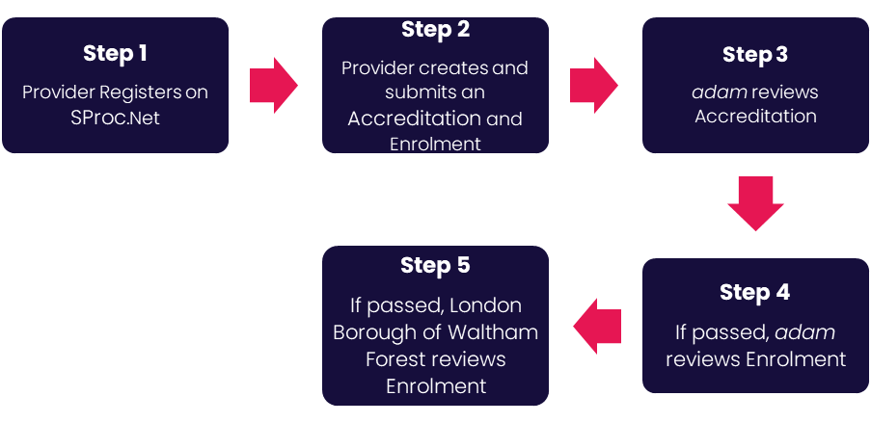
Please note that if either the Accreditation or the Enrolment is failed by the adam Team, the provider will receive feedback so amendments can be made. Equally, if the Enrolment is Rejected by the team at Waltham Forest, the provider will receive feedback so amendments can be made. Typically, the cycle of these steps will take a maximum of 10 working days.

Registration

Register
You must register your company on the system (https://www.sproc.net). If your office/facility/business is part of a larger parent group, then the registration must be completed at Head Office level. The below shows what is required:
• Business name
• Registered trading name (if different from the above)
• Business tax/VAT number
• Charity registration number (charities only)
• Company registration number (companies only)
• SME status
• Registered business address (Address line 1, City, Postcode etc.)
• Telephone number
• Email address

Add a system user
Once the company details have been filled in, you will then need to create a System User which will require the following:
• First name
• Last name
• Job title
• Email address

Once the above fields have been completed and the first User has been created, they will receive a username and temporary password. Upon logging into SProc.Net, the User will be prompted to change their password. The User will have the ability to add other company users on the system through the ‘Admin’ tab.

Add a location
If your organisation has multiple locations or offices, it is possible to add these additional locations once the company has been registered.

To add a location, go to the admin tab > My Company > Locations > New, and then follow the steps to fill in the details for the location. This will include:
• Location display name
• Address

Accreditation & Enrolment

The Accreditation and Enrolment forms make up the application criteria to join London Borough of Waltham Forest’s approved provider list. The tables below show the questions that providers will have to respond to. Some questions will only have to be answered depending on the response to another question.

Accreditation

To start a new Accreditation, you will need to first click on the ‘Accreditations’ tab at the top of the system page and then ‘New’. The following options will then need to be selected:

Client: London Borough of Waltham Forest

Category: Home Based Support

After this has been chosen, you can then complete the questions below.

This table shows the question that will need to be answered on the Accreditation form.

Q | Company Information | Trigger/Response
1 | Are you registering to provide Home Support Services to London Borough of Waltham Forest?

Enrolment
Once the Accreditation is complete, the Enrolment can be started immediately. You do not have to wait for the Accreditation to be approved, however your Enrolment can only be reviewed by adam after you have an Approved Accreditation.

You will first be asked to enter your location because Enrolments are location specific. This is done by clicking into the ‘Supplier Location’ box and selecting your location using the green triangle to the right of the address.

This table shows the questions which will need to be answered as part of your Enrolment. If a question is not applicable to your organisation, you must insert N/A to proceed.

Q | Question | Trigger
1 | Please confirm if you are currently a registered provider on Waltham Forests Framework?
2 | Please confirm you accept the statement below  'London Borough of Waltham Forest does not guarantee that your application will be evaluated and/or progressed if the Council feels that it has capacity in the current Homecare Framework' | 1 (No)
3 | Does your organisation operate the CM2000 Call Confirm Live and Finance Manager system, so invoices can be reconciled and paid via Finance Manager? | 1 (No)
4 | In addition to operating the CM2000 Call Confirm live and Finance Manager system, does your organisation use timesheets signed by the resident/family member to record visits? | 1 (No)
5 | Please confirm your organisation has audited accounts for the last financial year? | 1 (No)
6 | Do these accounts show your organisation in a profitable position? | 1 (No)
7 | Please confirm that your organisation has the level of insurance indicated below  Public Liability Insurance = £10 million | 1 (No)
8 | Is your organisation's CQC rating good or outstanding? | 1 (No)
9 | Does your organisation have medication, safeguarding and other policies related to the service provision for homecare and are these policies in date? | 1 (No)
10 | Does your organisation have escalation and business contingency policies in place? | 1 (No)
11 | Have your staff undergone a Disclosure Barring Service check and been assessed as suitable to work with Vulnerable Adults and Children? | 1 (No)
12 | Does your hourly rate include Nation Living Wage/London Living Wage? | 1 (No)

This table shows the documents which will need to be uploaded as part of your Enrolment.

Documents | Instructional text
Public Liability (Optional) | If you have answered 'Yes' to Q7, you do not need to upload a copy of your Public Liability Insurance. However, if you do want to upload a copy, please upload it here.

Adding service categories
The below Service Categories show the groups that London Borough of Waltham Forest are including in their new Home Support Category. The Borough has decided to have one general category for all providers. You will need to select the below category which says ‘All’.

Service Category
All

Distribution Override Groups

Requirements for care, will be sent out via Distribution Override Groups. These are based on geographical location and the services you can provide. When the portal for completing your A&E opens, you will be sent an email clarifying which group you must pick on your application.

Distribution Override Group | Only Select If
Lot 1 | You are a Lot 1 Framework provider
Lot 2 | You are a Lot 2 Framework provider
Lot 3 | You are a Lot 3 Framework provider
Lot 4 | You are a Lot 4 Framework provider
Lot 5 | You are a Lot 5 Framework Provider
All Framework Providers | You are a Framework Provider
Spot Purchaser | You are not a Framework Provider
Re-ablement | You provide Re-ablement Services

Next steps
Following submission, the Accreditation and Enrolment will be reviewed by the adam team, and the Enrolment by London Borough of Waltham Forest. You will receive a system notification email to inform you of the outcome of each review stage.

For more details on how to create and submit your Accreditation and Enrolment information, please see the Accreditation and Enrolment User Guide available at X under the ‘Supporting Documents’ section.

To register and begin your application, visit www.sproc.net

If you have any questions or concerns which specifically relate to this Accreditation and Enrolment criteria, please email surinder.sohotey@walthamforest.gov.uk.
For system/technical support with your application – use the Live-Chat function whilst logged in to SProc.Net to speak to an adam Support Team member.

