Provider Onboarding – Training Guide

The purpose of this guide is to inform you how to register, accredit and enrol onto SProc.Net

Registration
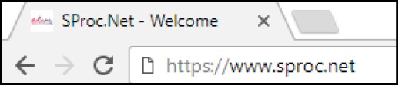
The first step is register with SProc.Net to get a username and password. You do this by typing SProc.Net into the search bar of your browser.

You then click Get Started
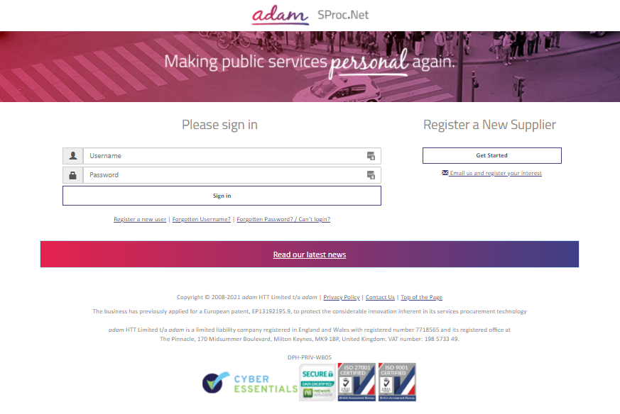

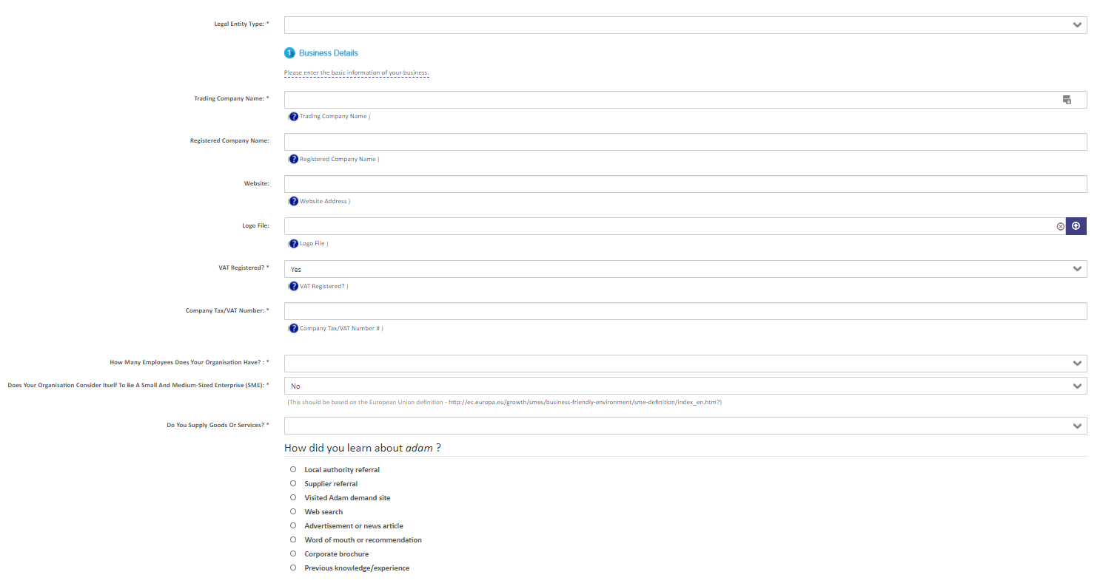
You are then required to enter information about your company. This will include information such as:
- Business Name
- VAT Registration
- Number of Employees
- Business Address
Please note: when entering your address within ‘Address/ Contact Details’ section you must enter a post code first and then select your address from the drop down.

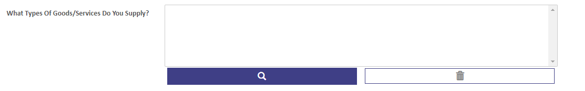
Please note: When filling in ‘What Types of Goods/Services Do You Supply’ box please click on the magnifying glass to select available options (this section may also be left blank as it is optional).
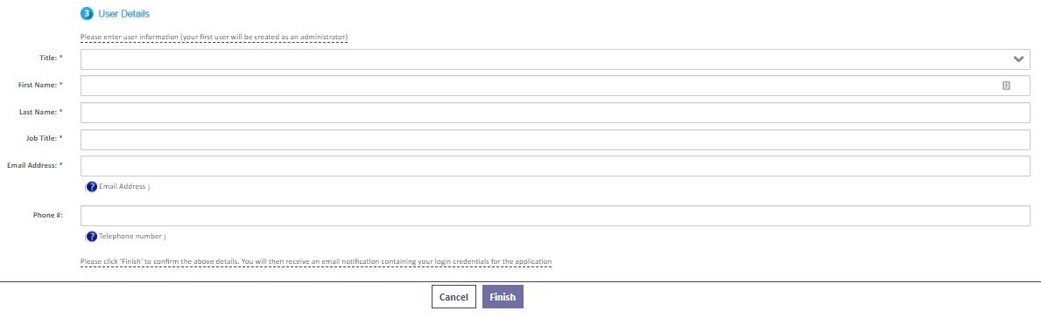

On the second stage of the process, you will be required to enter some user information.
(You will be able to add more users at a later stage)

When you click Finish you will be sent an email with a username and password. Use these credentials to Log in and begin your Accreditation.

(Please note that you will be required to change your password when you first log on.)

Accreditation

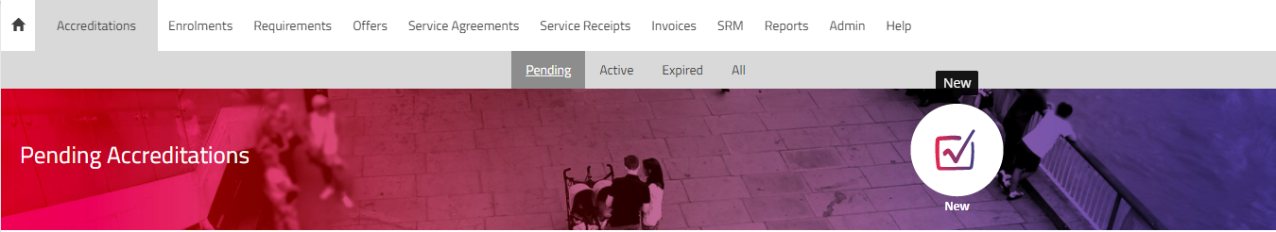
Once you have logged onto the system to start your Accreditation, click on ‘Accreditation’ tab in the top left corner and then click ‘New’ icon.

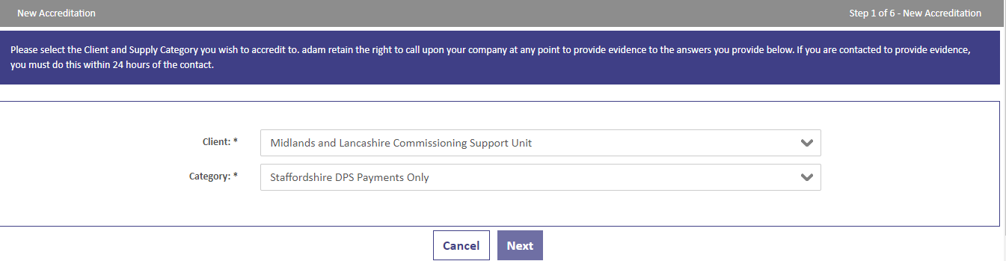
From the drop-down boxes, you will need to select the Client ‘Midlands and Lancashire Commissioning Support Unit’ and the ‘Staffordshire DPS Payments Only’ category. You then click ‘Next’.
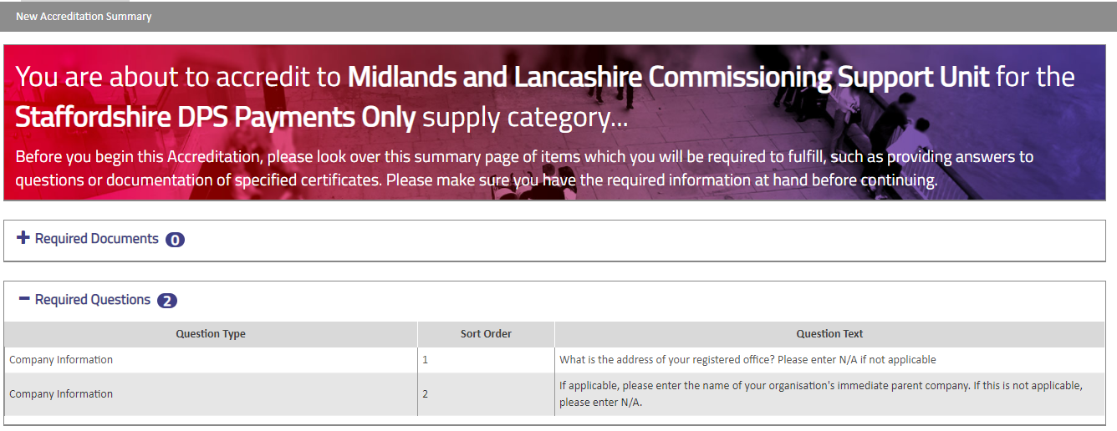
This is where you can see your Accreditation summary. Click “Next” to proceed further.

On this page you are required to download two contracts ‘Self Bill Document’ and ‘Declaration Statement’ (click on ‘Download File’ to Download and read through it). Once you have read through both contracts you will need to tick boxed below ‘I Agree To The Terms Of The Document’ and ‘I Am Authorised To Agree’ to sign both contracts.

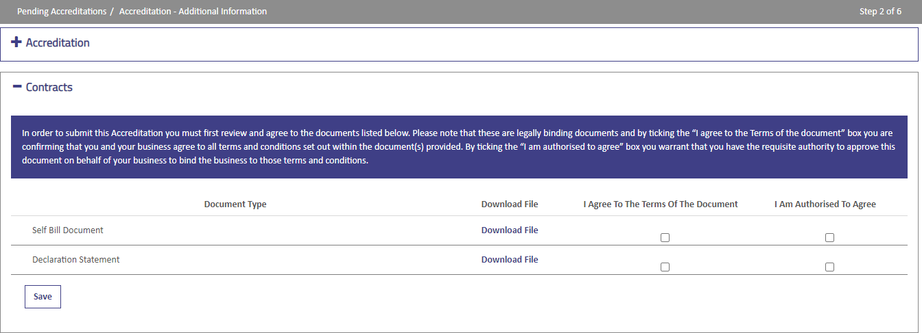

Further down the page you will see list of questions related to your current contractual relationship with Midlands and Lancashire Commissioning Support Unit. You will need to answer these questions and click ‘Next’ to proceed further.
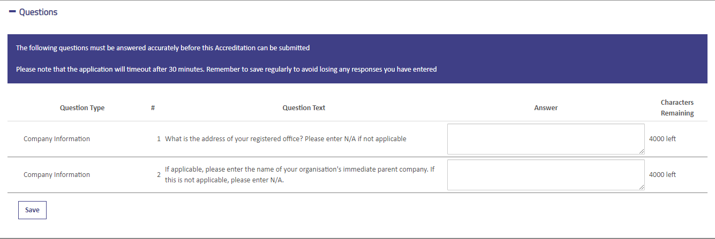

You will then need to confirm that you are certified to accept responsibility for submitting this accreditation on behalf of your organisation. You do this by ticking the box and clicking ‘Submit’.
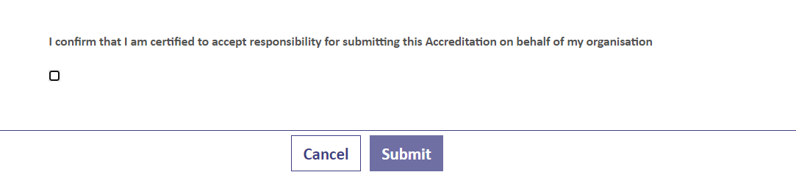

Enrolment

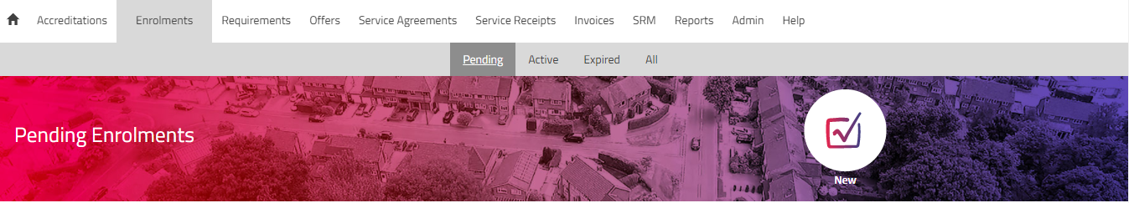
Once you have completed your Accreditation you can start your Enrolment. To start a new Enrolment, you will need to click on ‘Enrolments’ tab and a ‘New’ icon.

You will now need to click on a magnifying glass icon and select the Accreditation that you have just created for ‘Midlands and Lancashire Commissioning Support Unit’ and the ‘Staffordshire DPS Payments Only’ category to start a new Enrolment. Once done, click ‘Next’ to proceed further.
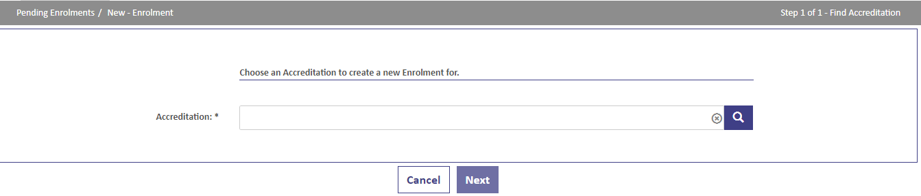

On this page you will need to select your company from the supplier location box (to select click on a magnifying glass icon) and click ‘Next’ to proceed further.
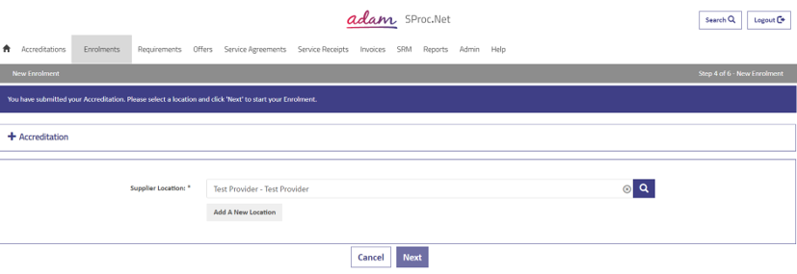

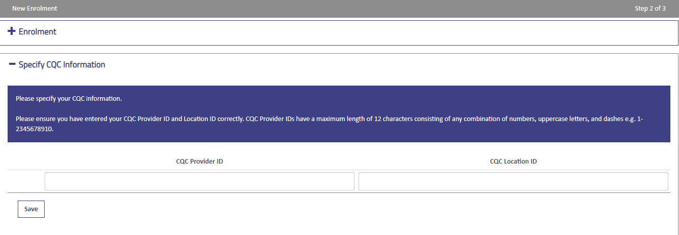
You will then need to enter your CQC Provider ID and CQC Location ID in boxes provided (this is optional, therefore if you do not have these ID’s you may leave It blank).

You will also need upload your bank details on company letter headed paper (this should include Bank Name, Account Name, Sort Code, and Account Number). To upload your bank details, click on a blue icon within File Name column then click on ‘Upload a file’ to select it from your device and click ‘Ok’.
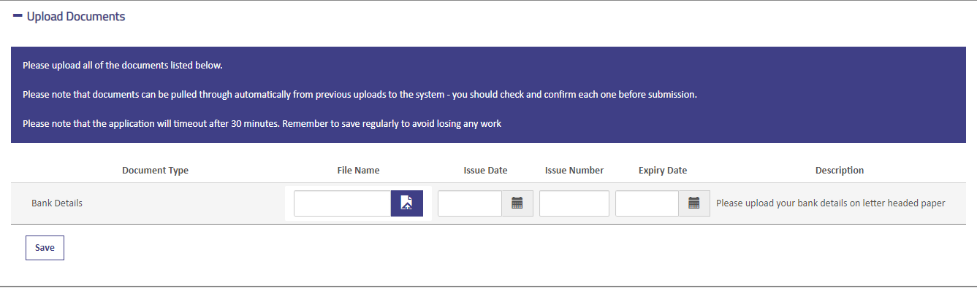
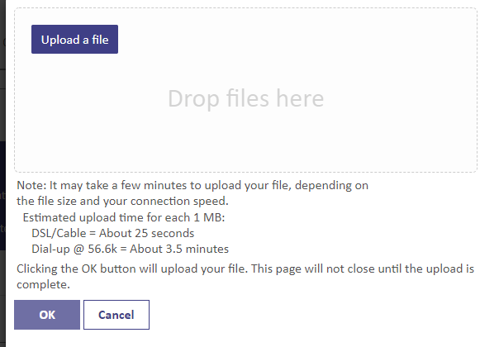

You will then need to select the Service Categories (please make sure to select all Service Categories). To select Service Categories, click on ‘Find more Items’.

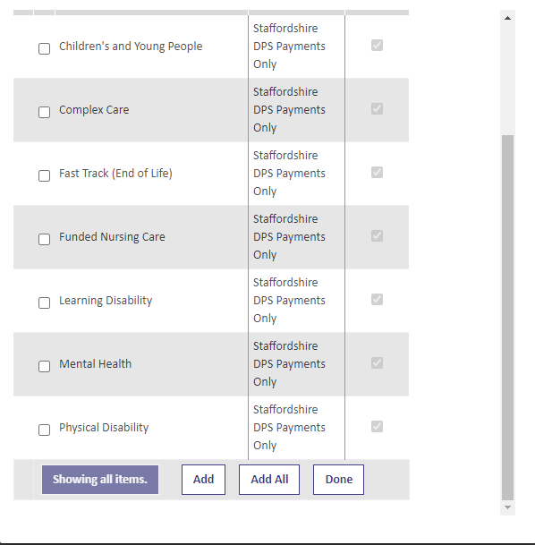
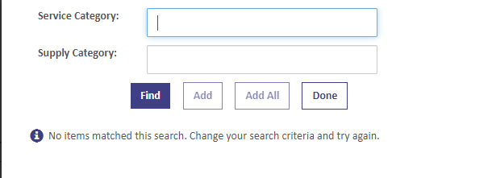
Then click on ‘Add all’ to add all Service Categories and ‘Done’ to complete.

Further down the page you will need to add your bank details and tick ‘I agree that I am certified to accept responsibility for submitting this information on behalf of my business *’ box. Click ‘Finish’ once completed.
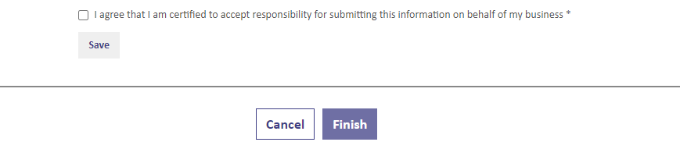
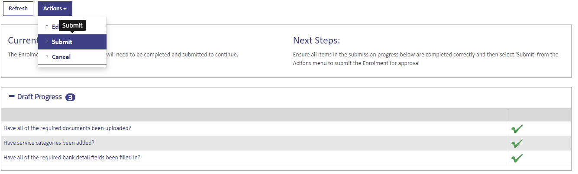
Your Enrolment should now be ready to submit. Click on the ‘Actions’ button and select ‘Submit’ option to submit the Enrolment.

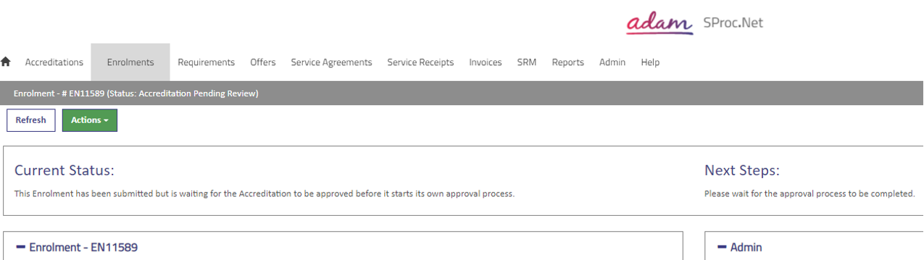
Your Enrolment is now complete and will require approval from adam.

Help and Support

If you are experiencing any difficulties or need any assistance, please do not hesitate to contact the Support Team.

You can do this by clicking the ‘Need Assistance’ button that is in the bottom left corner of the screen between 08:30am – 17:00pm Monday – Friday to talk to one of our Support Consultants.

