FAQ
Doncaster Council
Passenger Transport Service

- When does the A&E application need to be completed by?
We are aiming for providers to have their Accreditation and Enrolment completed by 16th September. We have a final drop-in session scheduled for the 13th September and strongly encourage providers to sign up if they are struggling with the process. Please copy and paste the following link into your browser to register https://us02web.zoom.us/webinar/register/WN_3RTnJBFzR8urpDl-kJhhLA
You will still be able to apply to join the DPS after this date but 13th September is the final drop in session.

- How do I answer Q25 on the Accreditation which asks for sub-contractor details and information, if I don’t know which sub-contractor will be used for which contract?

If you plan to use sub-contractors, please download the template and fill out as much information as you can based on the sub-contractors you work with currently. Once on the DPS, please alert the council of any new sub-contractor you intend to use. We consider sub-contractors to be anyone who you hire to do work on your behalf. For example, if you are a transport organisation hiring either sole traders or another organisation to provide transport services on your behalf.

- For Q19 on the Enrolment, can I upload contract examples that I already have with the council?

Yes, if you already have contracts with Doncaster Council. These can be used as an example. Please download the contract example form from the downloadable template section, complete and re-upload it. Please note you can upload up to 3 examples, I.e. if you only have one example, that is acceptable.

- What should I upload for Employers liability if I am a sole trader?

If you are a sole trader, please upload a document saying so and therefore, this type of insurance is not relevant to you. You can upload this as a word document to the Employers liability section. However, you may wish to seek independent advice regarding liability for self-employed staff working for you

- Where can I find the Single Procurement document?

If your organisation has completed this document, please upload it onto the system under the ‘Single Procurement Document’ on then Enrolment. However, this is optional and if your organisation has not completed this document, then you do not need to.

- I only have £5m public liability insurance, what should I do?

Doncaster Council require suppliers to have £10m in cover for public liability which needs to be uploaded onto the system. Once you have £10m in cover, please upload this onto the Enrolment for review. You will not be able to join the DPS or bid for work until such time as this has been done.

- What if I need to upload multiple documents at once?

Please upload a ZIP folder with the documents required inside. Instructions how to do so are below.
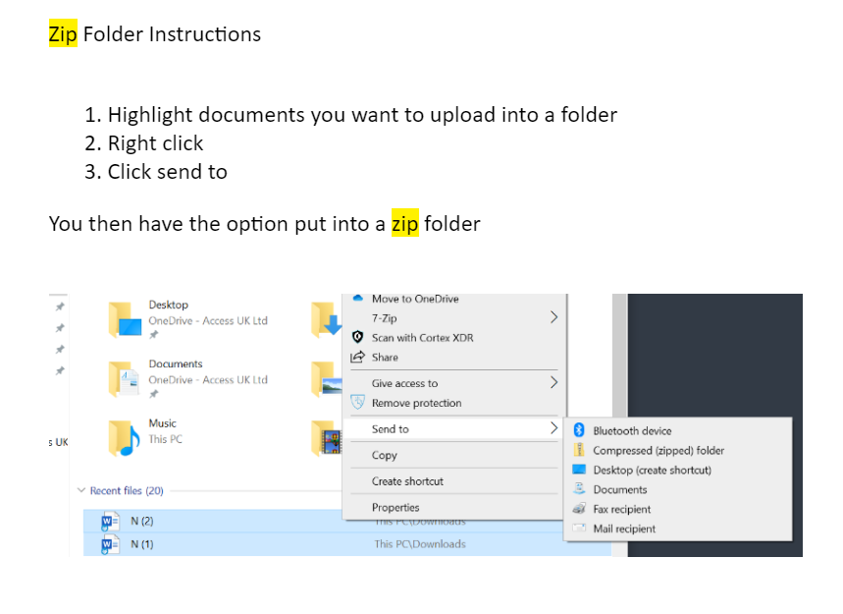

- If my drivers and I have valid hackney licences, what should we do?

Please upload a copy of all driver's licences, using a ZIP folder (method in the question above).

